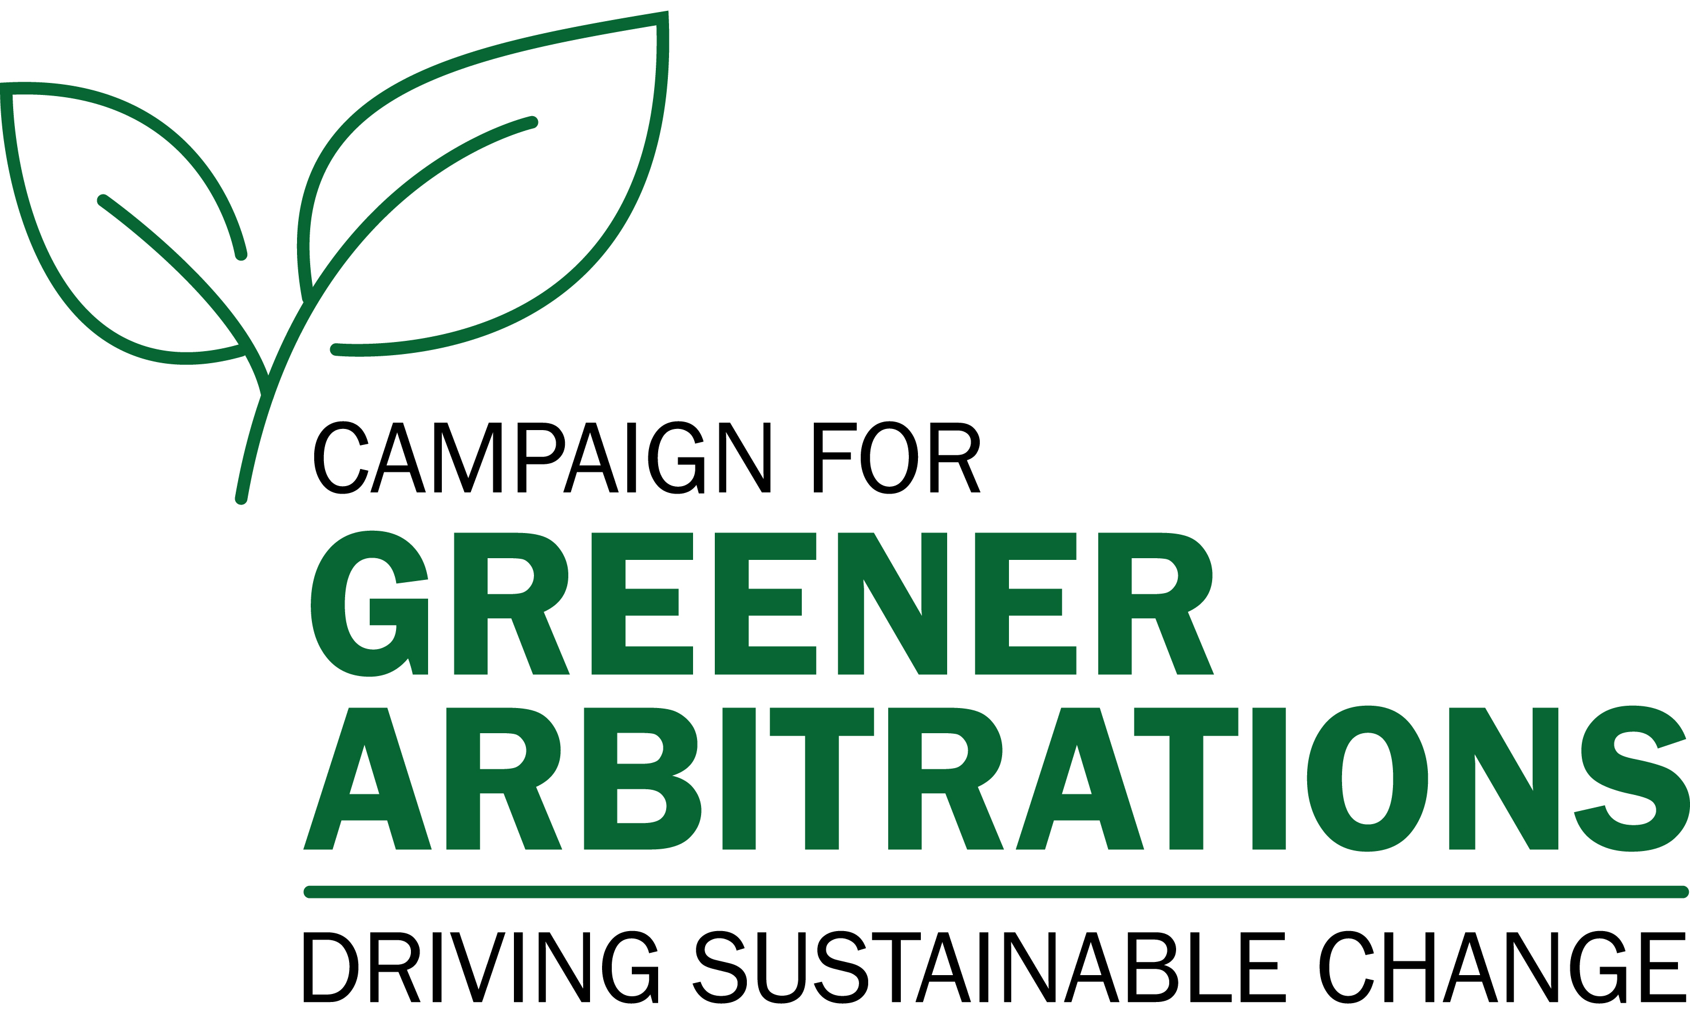

THE CAMPAIGN FOR GREENER ARBITRATION

Model Clause for Company Outside Counsel Retention

Purpose

This model clause (Article [_]) draws on principles expressed by the Campaign for Greener Arbitrations and is for use by company legal departments to assist in reducing carbon emissions and other environmental impact associated with managing and resolving disputes. It can be incorporated in part or in its entirety in company guidelines or policies relating to external counsel, or for inclusion in counsel engagement letters, or adapted as appropriate.

Art. [_] Reduction of Environmental Impact and Waste

[Company’s name] is seeking to reduce carbon emissions and other environmental impacts associated with a number of activities, including resolving disputes. [Company’s name] [has adopted/adhered to/agrees with] the principles expressed in the Green Pledge and the Green Protocol for Law Firms, available at the Campaign for Greener Arbitrations’ website.

Outside counsel will make efforts, consistent with [company’s name]’s objectives, to minimize the impact of the resolution of disputes on the environment, including, by way of example:

Travel

- Consider and question the need to fly or the number of people who will fly, and consider instead the use of virtual meeting and hearing technology, including for document review, witness interviews, client meetings, and hearing participation.

- Make reasonable efforts to offset the carbon emissions of any flights taken on [company’s name] matters.

- Where available and appropriate, consider the use of train travel as a lower-carbon emitting alternative to flying.

Documents

- Whenever reasonably possible, conduct correspondence through electronic means unless hard copy documents are expressly required under the circumstances.

Hearings

- Consider whether certain issues genuinely require a hearing of any type (virtual or physical presence) to advance [company’s name]’s interests in the dispute or whether one or more issues may be decided on the basis of documents and written submissions only.

- Where a hearing is considered necessary or advantageous for [company’s name]’s interests, consider whether it genuinely requires the physical, in-person attendance of all participants, or whether some or all of the participants, including witnesses and experts, may participate through virtual hearing technology rather than by traveling to a hearing location.

- Whenever possible, discourage the use of hard copies of documents in arbitrations and instead encourage the use of electronic documents.

Disclaimer

The Framework and the Green Protocols are not binding and are not intended to displace applicable rules or derogate from the arbitration agreement unless and to the extent the parties so agree (either in the arbitration agreement or subsequently) or the tribunal so orders.

The Framework and the Green Protocols do not establish liability or a liability standard for legal or regulatory purposes.

